Title (Times New Roman, Bold and Font Size: 14)
Author name (put * after the name of corresponding author) (Times New Roman, Bold and Font Size: 10)
Author affiliation (Times New Roman, Font Size: 9)
Author email id (Courier New, Font Size: 9)

Abstract (Times New Roman, Bold and Font Size: 10)

Keywords: (5-6) (Times New Roman, Bold and Font Size: 10)

- Introduction (Times New Roman, Bold and Font Size: 12)
Currently under development are arrhythmia monitors for ambulatory patients which analyze the ECG in real time [1] - [3].Software QRS detectors typically include one or more of three different types of processing steps: linear digital filtering, nonlinear transformation, and decision rule algorithms [4]. (Body text:-Times New Roman, Font Size: 10)

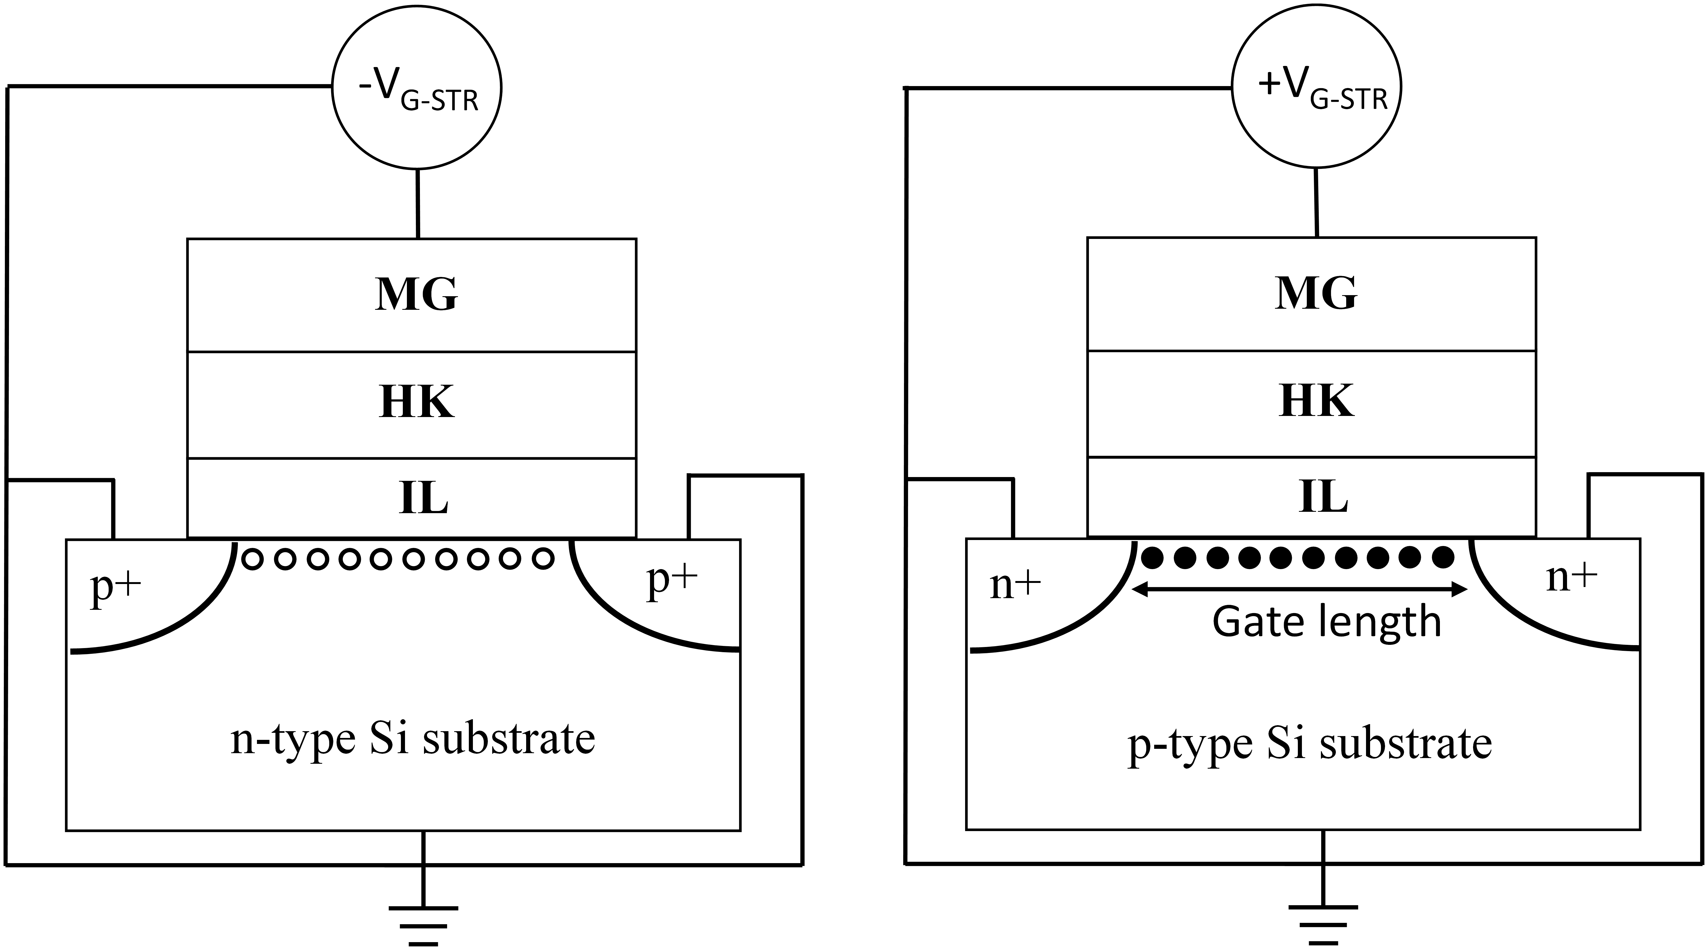
Fig. 1. Fig Caption (Times New Roman, Font Size: 9)
  - Next Heading (Times New Roman, Bold and Font Size: 10)
(Body text:-Times New Roman, Font Size: 10)

1.1.1 Sub heading (Times New Roman, Bold, Italic and Font Size: 10)
(Body text:-Times New Roman, Font Size: 10)

Table 1. Table caption. (Times New Roman, Font Size: 9)

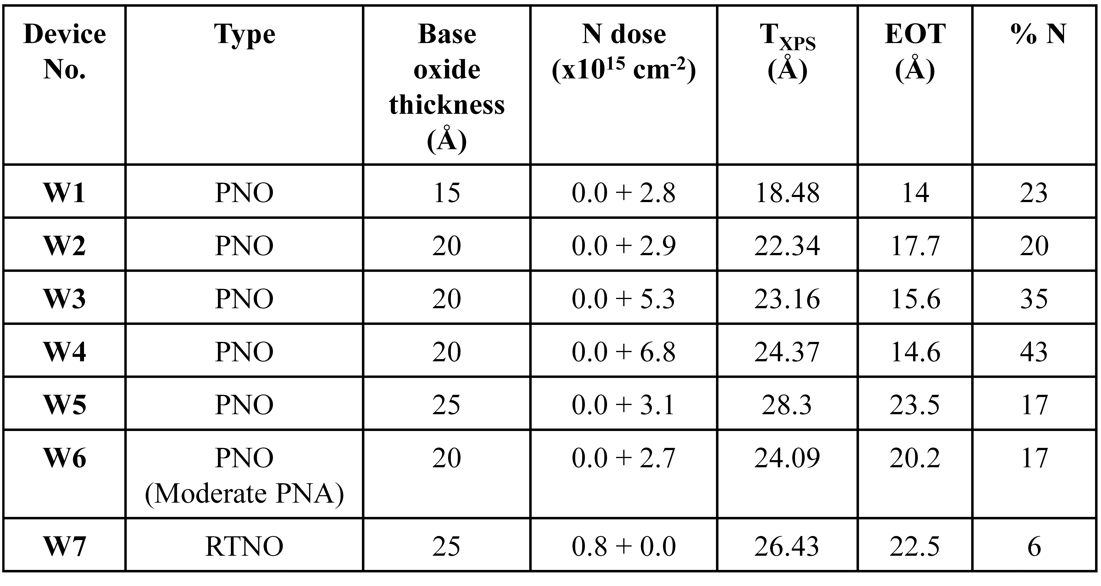

4 Summary/Conclusion (Times New Roman, Bold, Font Size: 12)
(Body text:-Times New Roman, Font Size: 10)
References: (Times New Roman, Font Size: 12)
[1] Thakor N. V., Webster J. G., and Tompkins W. J.: Design, implementation, and evaluation of a microcomputer-based portable arrhythmia monitor. Med. Biol. Eng. Comput., vol. 22, pp. 151-159, (1984).
[2] Mark R. G., Moody G. B., Olson W. H., Peterson, P. S. Schulter S. K., and Walters J. B., Jr.: Real-time ambulatory arrhythmia analysis with a microcomputer. Comput. ardiol., pp. 57-62, (1979).
[3] Patomaki L., Forsti J., Nokso-Koivisto V-M., Jokinen, Y.and Lansimies E.: On line recording and analysis of the ECG in ambulatory patients. Comput. Cardiol., pp. 173-175, (1981).
[4] Pahlm 0. and Sornmo L.: Software QRS detection in ambulatory monitoring-A review. Med. Biol. Eng. Comput., vol. 22, pp. 289-297, (1984).

(Reference Text: Calibri, Font Size: 10)

Guideline for Reference Citations in Text
Reference numbers in square brackets with sequential by citation [1]-[3], [4] etc, (Please refer the sequential way it is cited in Introduction and same numbered in Reference Sections, i.e. [1], [2], [3], [4] etc.)

