To take permissions for images:
Create an account with copyright.com:
Go to www.copyright.com
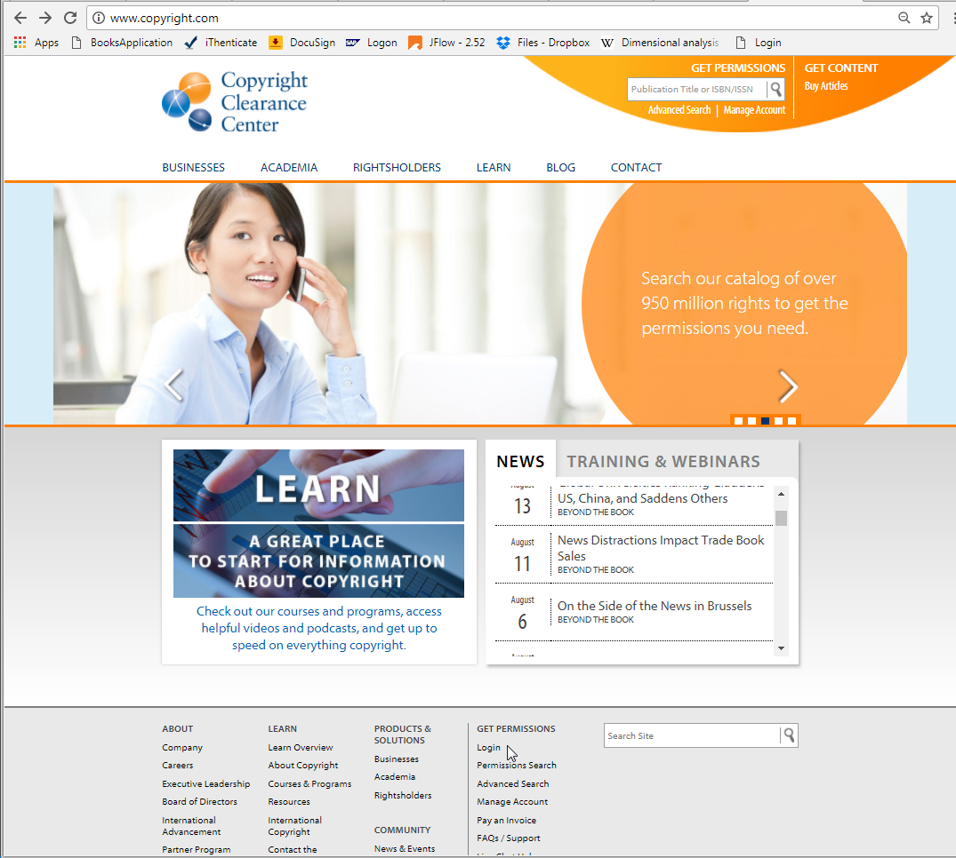

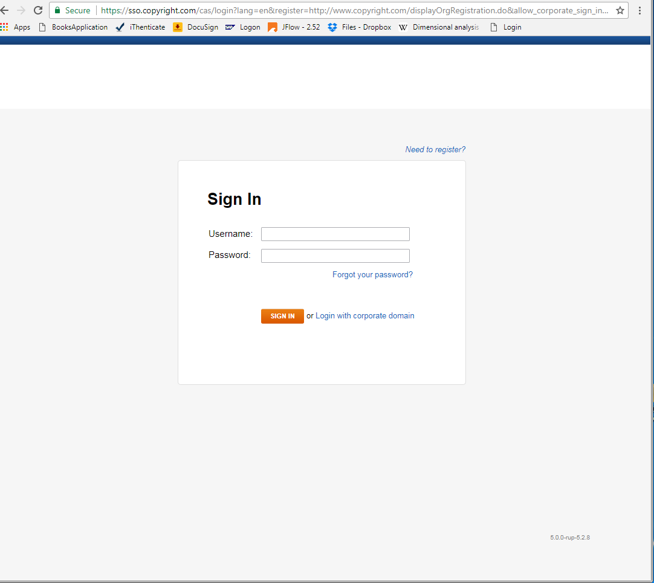

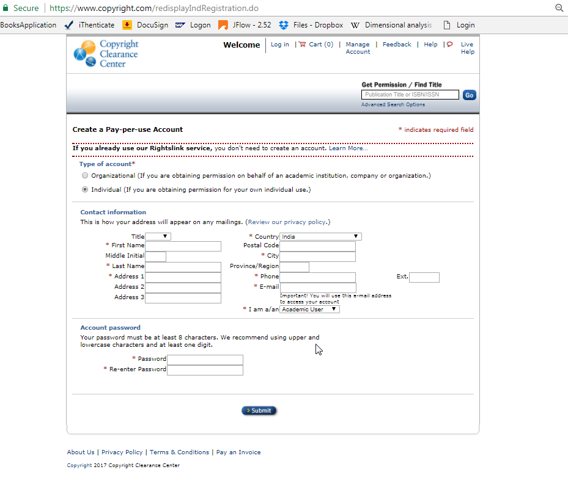
In type of account select “Individual”
In I am a/an select “Academic User”

For Permissions:
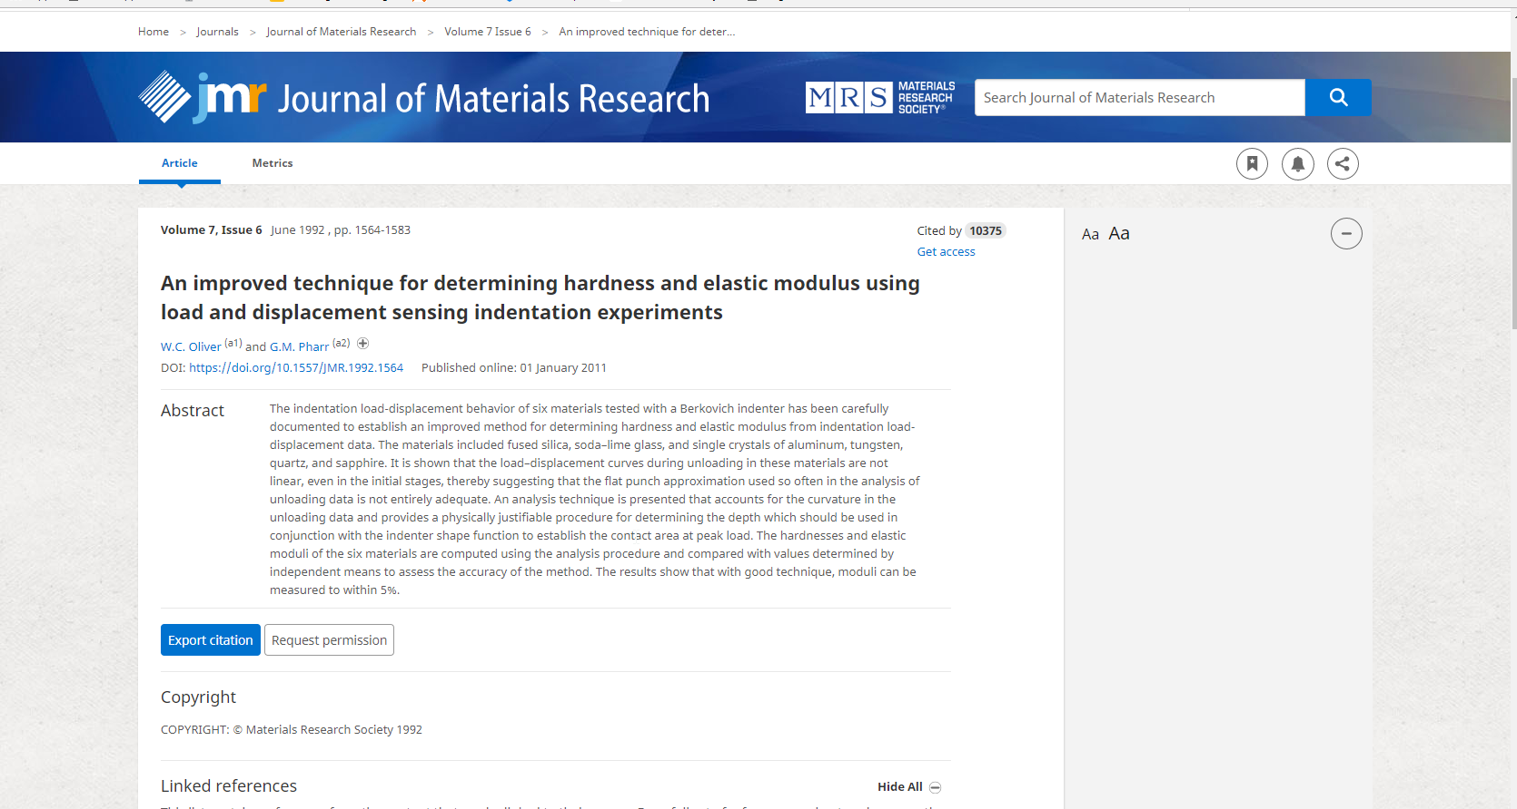
When you click on “Request permission” tab, the link will open in a new tab, where the details are to be filled in as follows (the number of figures entered will vary)
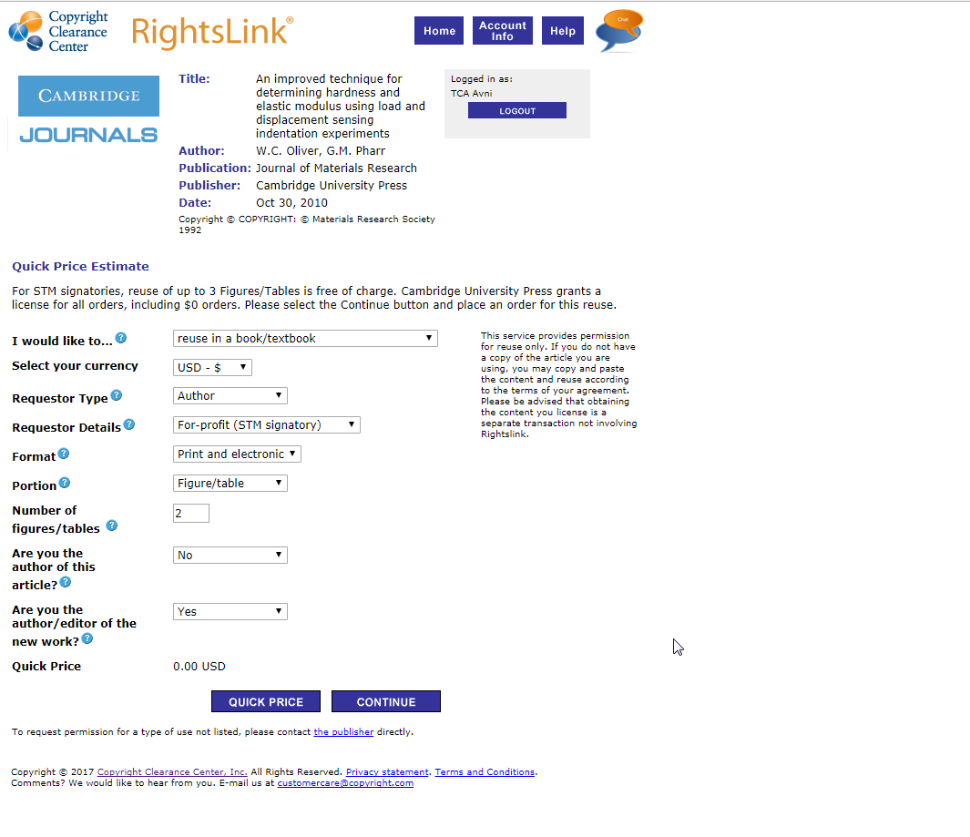
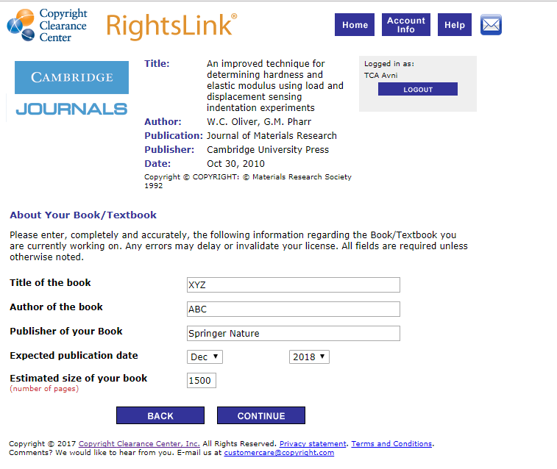
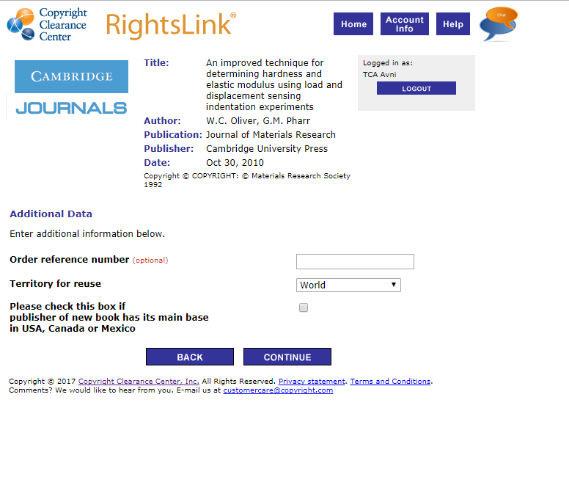
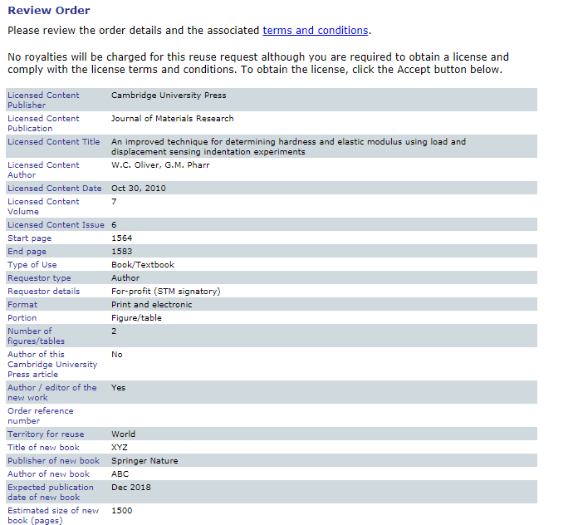

Fill in the necessary details and select Accept. Download the PDF report generated

